Specifications
  - SCHW-ALZ-0061 List&Label OI Report Order Category Cost Object
Doc Version 1.0

Customer: | Schwind eye-tech-solutions GmbH
Project: | Schwind eye-tech-solutions InBase
Proalpha version: | 7.2d
Proalpha Installation(s): | DE
Product variant: | │ Proalpha ray  ☒ Proalpha classic  Note: If "Proalpha ray" is enabled, the following is also done Always implemented in the classic client.
GUI language: | German
Author: | Bernhard Altziebler
Created on: | 21.10.2025
Last change on: | 21.10.2025
Contact Customer: | Mrs. Hock

This document describes a modification or expansion of the standard software in Proalpha in the product variant defined above and has been checked by the customer. The functional design in chapters 2 - 4 is hereby released for technical specification and costing in compliance with the requirements in section "Final Provisions":

......................................................
Date and Signature of Customer

Contents
1. [UPDATE THE TABLE] 3
1.1 [UPDATE THE TABLE] 3
1.2 [UPDATE THE TABLE] 3
2. [UPDATE THE TABLE] 4
2.1 [UPDATE THE TABLE] 4
2.2 [UPDATE THE TABLE] 6
3. [UPDATE THE TABLE] 7
3.1 [UPDATE THE TABLE] 7
4. [UPDATE THE TABLE] 8
4.1 [UPDATE THE TABLE] 8
4.2 [UPDATE THE TABLE] 8
4.3 [UPDATE THE TABLE] 8
5. [UPDATE THE TABLE] 9
5.1 [UPDATE THE TABLE] 9
5.1.1 [UPDATE THE TABLE] 9
5.1.2 [UPDATE THE TABLE] 9
5.1.3 [UPDATE THE TABLE] 9
6. [UPDATE THE TABLE] 10
7. [UPDATE THE TABLE] 11
7.1 [UPDATE THE TABLE] 11
7.2 [UPDATE THE TABLE] 11
8. [UPDATE THE TABLE] 12

Requirements

References
Case CS0482854 forms the basis for this specification sheet.

Description of requirements
The Purchase Order, Order Category and Cost Object fields of the linked document are to be added to the List & Label data basis of the open items list.

Functional design

Description of the solution
The purchase order can already be printed in the standard version and therefore does not have to be extended.
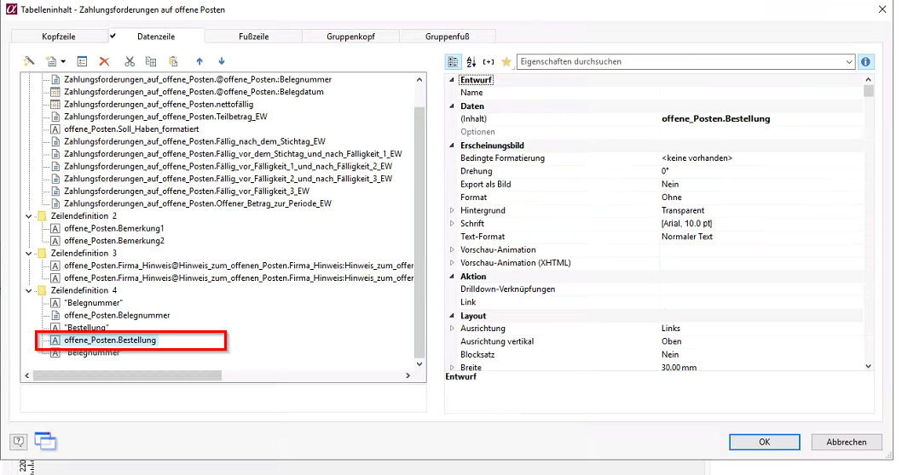
The order category and the cost object of the document header are adopted into the data basis during the adjustment.
The data basis of the "Open Items" report (FOOPLN)
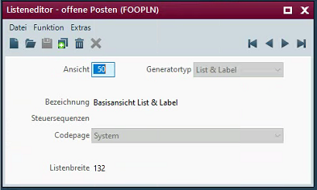
The order category and the cost object of the document header are added:
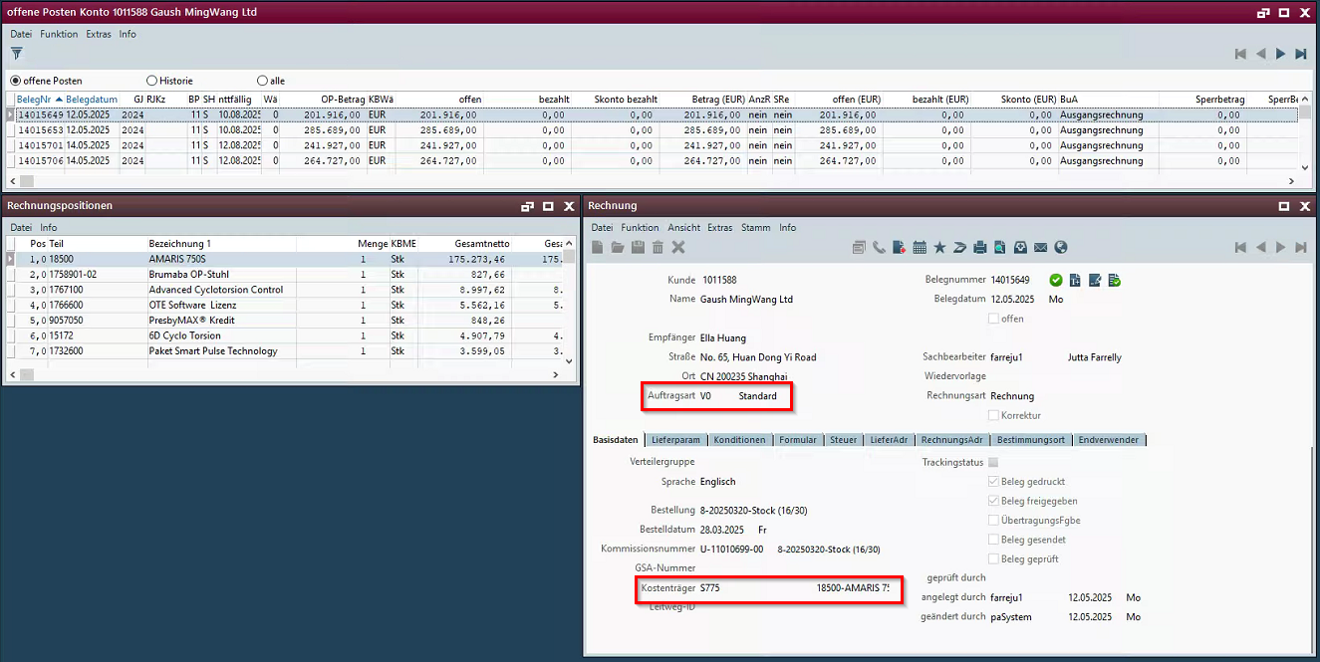
There should be 2 fields for the order category and the cost object. First the order category or the cost object itself and then the description.
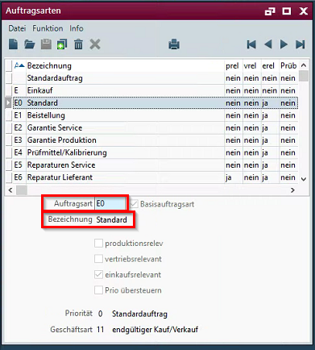
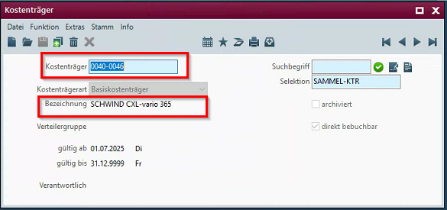

Differentiation
The customization refers to the tables, fields and programs mentioned.
This specification sheet does not automatically add functional extensions to the adjacent modules of the Proalpha environment, such as the DMS, Analyzer, reports, and forms. The Proalpha help is not automatically expanded.
Changes to adjacent modules/programs must be described and defined in the specifications sheet. It also includes changes to the graphical user interface. If Ray is not explicitly mentioned here, the present modification refers to the Classic Proalpha client.

Test cases
The specified test cases map the customization described here and are the basis for the acceptance of the software.

Printing the OI report
Pt | Explanation | Expected result | Test data
 | Printing the OI report | The 4 new fields are printed. | Account 1011588
 | Test result (incl. screenshots)

Requirements

Technical Requirements
The use of Proalpha functionalities outside the concurrent user model (connection of external systems, background processing) requires the licensing of so-called software services.
"Use of Proalpha functionalities" refers to any use or access to the Proalpha infrastructure, e.g.
- Writing to Proalpha data structures
- Calling Proalpha classes and other business logic
- Access to Proalpha Services
The implementation described in the specifications therefore requires the following software services:
- <Please list services here, otherwise delete section>
- ...

Organizational Requirements

Notes about the go-live

Technical Design

<Template for Section>

GUI

Business Logic

Data Model

Final Provisions
These specifications form the basis for customer-specific expansions of the standard software Proalpha®.
The customer-specific extensions only cover the area defined in this specification sheet. Functionality beyond this scope is not provided.
Unless explicitly agreed otherwise, the customer-specific extensions are only created in German: no programs, program parts or data are translated into other languages. This also applies to the languages supported by Proalpha® in the standard version.
The customer-specific extensions are thoroughly tested before they are delivered. However, for technical reasons, it is not possible to perform the test under the same conditions and with the same data as the customer will use. It is therefore recommended to carefully check the functions in the real system environment after their delivery.
The Customer is aware that variances in the display details or handling of the functions defined in this specification sheet may be required for the transfer of the functions defined in this specification sheet to new versions of Proalpha®. This specification sheet also remains valid in this case, provided that there is a maintenance agreement for the customer-specific extensions defined in this specification sheet and no changes to the functionality have to be agreed on.
This specification sheet documents the customer-specific extensions. No other documentation beyond the specifications contained in this specification sheet is to be provided. Questions about customer-specific extensions are received and forwarded by the hotline.
By signing on page 1, you confirm:
- that the specification sheet is accepted in this version and becomes part of the contract,
- that this specification sheet defines the functional scope of the software to be created and that there are no side agreements regarding the functionality,
- that a technical specification is created for the specification sheet, which is then invoiced separately if the quote for the implementation of the specification sheet is not ordered in the context of the quote validity.

Annex

Table of Figures
No entries could be found for a table of figures.

Table of tables
No entries could be found for a table of figures.

Change History
Doc.  Version | Date | Specialist | Initiator | Chapter | Explanation
1.0 | 21.10.2025 | Bernhard Altziebler | Mrs. Hock | All | Initial new entry

